

**Software Testing**

**Ammara Yasir BSE173057**

**Anum Ashfaq BSE173060**

**Komal Zahra BSE173050**

**Submitted To:**

**Sir Samir Obaid**

Capital University of Science and Technology, Islamabad

Table of Contents

**Code Introduction** 2

**Apply MCDC to implement the test cases.** 2

**Decision Statement 1.** 2

**1.1 Implementation** 2

**Decision Statement 2** 3

**1.1 Implementation** 3

**Flow Chart:** 4

**Path Predictions:** 4

**1st Path Prediction:** 4

**Path:** 4

**Expressions:** 4

**2nd Path Prediction:** 4

Path: 4

**3rd Path Prediction:** 5

**Path:** 5

**Expressions:** 5

**Test Oracle:** 5

**Expected Outputs**: 5

# **Code Introduction**

This code is a check out checker to check the details of customer to give them a discount on total bill where it take (Total Price, Total Items, and Voucher Number).

If the Total Price is greater than and equal to 20,000 Rs, Total Items are greater than 10 and voucher number is in between of 10 to 15 than customer get 20% discount.

If the Total Price is less than 20,000 Rs, Total Items are greater then and equal to 10, voucher number is in between of 1 to 10 than customer get 10% discount.

# **Apply MCDC to implement the test cases.**

## **Decision Statement 1.**

if(TotalPrice >= 20000 && TotalItems > 10 || NoOfshop >= 5 && NoOfshop <=10 )

|  |  |  |  |  |
| --- | --- | --- | --- | --- |
|  | **Inputs** | | | **Outputs** |
| **Test** | **Total Price** | **Total Items** | **NoOfshop** | **Total Price && Total Items && NoOfshop** |
| 1 | T | T | T | T |
| 2 | T | T | F | T |
| 3 | T | F | T | T |
| 4 | T | F | F | F |
| 5 | F | T | T | T |
| 6 | F | T | F | F |
| 7 | F | F | T | T |
| 8 | F | F | F | F |

### **1.1 Implementation**

|  |  |  |  |  |
| --- | --- | --- | --- | --- |
|  | **Inputs** | | | **Outputs** |
| **Test** | **Total Price** | **Total Items** | **NoOfshop** | **Total Price && Total Items && NoOfshop** |
| 1 | 25000 | 15 | 5 | T |
| 2 | 20000 | 11 | 1 | T |
| 3 | 30000 | 5 | 10 | T |
| 4 | 28000 | 10 | 2 | F |
| 5 | 15000 | 20 | 8 | T |
| 6 | 10000 | 25 | 3 | F |
| 7 | 5000 | 4 | 7 | T |
| 8 | 3000 | 3 | 4 | F |

**Decision Statement 2.**

if(TotalPrice < 20000 && TotalItems <= 10 || NoOfshop >= 1 && NoOfshop <4)

|  |  |  |  |  |
| --- | --- | --- | --- | --- |
|  | **Inputs** | | | **Outputs** |
| **Test** | **Total Price** | **Total Items** | **NoOfshop** | **Total Price && Total Items && NoOfshop** |
| 1 | T | T | T | T |
| 2 | T | T | F | T |
| 3 | T | F | T | T |
| 4 | T | F | F | F |
| 5 | F | T | T | T |
| 6 | F | T | F | F |
| 7 | F | F | T | T |
| 8 | F | F | F | F |

### **1.1 Implementation**

|  |  |  |  |  |
| --- | --- | --- | --- | --- |
|  | **Inputs** | | | **Outputs** |
| **Test** | **Total Price** | **Total Items** | **NoOfshop** | **Total Price && Total Items && NoOfshop** |
| 1 | 5000 | 3 | 1 | T |
| 2 | 3000 | 4 | 5 | T |
| 3 | 2500 | 15 | 2 | T |
| 4 | 3500 | 12 | 6 | F |
| 5 | 21000 | 8 | 3 | T |
| 6 | 22000 | 9 | 7 | F |
| 7 | 25000 | 12 | 4 | T |
| 8 | 30000 | 15 | 8 | F |

# **Flow Chart:**

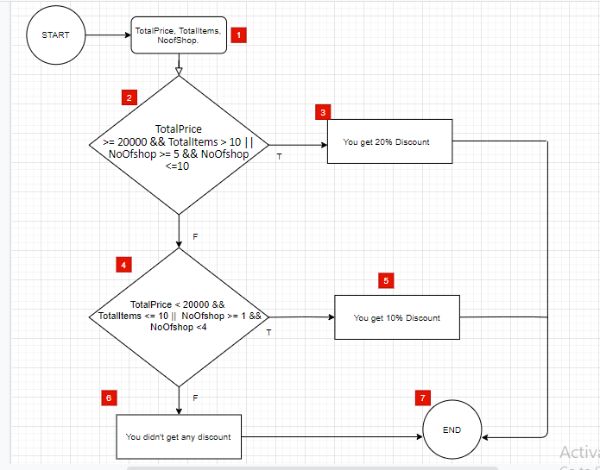

# **Path Predictions:**

## **1st Path Prediction:**

### **Path:**

1->2->3->7

### **Expressions:**

TotalPrice >= 20000 && TotalItems > 10 || NoOfshop >= 5 && NoOfshop <=10 **->** You get 20% Discount

## **2nd Path Prediction:**

### Path:

1->2->4->5->7

#### Expressions:

TotalPrice >= 20000 && TotalItems > 10 || NoOfshop >= 5 && NoOfshop <=10 **->**TotalPrice < 10000 && TotalItems <= 10 || NoOfshop >= 1 && NoOfshop <4 **->** You get 10% Discount

## **3rd Path Prediction:**

### **Path:**

1->2->4->6->7

### **Expressions:**

TotalPrice >= 20000 && TotalItems > 10 || NoOfshop >= 5 && NoOfshop <=10 **->** TotalPrice < 10000 && TotalItems <= 10 || NoOfshop >= 1 && NoOfshop <4 -> You didn't get any discount

# **Test Oracle:**

## **Expected Outputs**:

1. You get 20% Discount

2. You get 10% Discount

3. You didn't get any discount

|  |  |  |  |  |  |
| --- | --- | --- | --- | --- | --- |
| **Path** | **Input** | | | **Actual Outcome** | **Expected Outcome** |
| **Total Price** | **Total Items** | **NoOfShop** |
| 1->2->3->7 | 25000 | 15 | 5 | You get 20% Discount | You get 20% Discount |
| 1->2->4->5->7 | 5000 | 5 | 2 | You get 10% Discount | You get 10% Discount |
| 1->2->4->6->7 | -1 | 0 | 0 | You didn't get any discount | You didn't get any discount |